
Fees and Funding policy
Mini VIPs recognises the importance of funding to give families the opportunity to access childcare for a variety of reasons. We welcome families using all forms of funded hours with us, including 30 hours working parent entitlement, 2-year-old disadvantaged funding and the 3–4-year-old universal funding.
We recognise that every family has different childcare needs depending on their working circumstances and wish to be as flexible as possible to reflect this. Parents are able to use their funded hours during the term time only, spread throughout the year, and across one day – five days. There is no obligation to attend any hours over their funding and children are able to attend for only their 15 or 30 hours should they wish. We also allow contracts with a differing number of term time and holiday days, to maximise use of funded hours.
Our contracts are very flexible offering start and finish times in 15 minutes increments i.e. 7.45am, or 8.15am start, 4.30pm finish or 5.45pm finish, whichever is needed.
Please find below our funded hours and additional paid hours table (prices correct as of 1st May 2026):
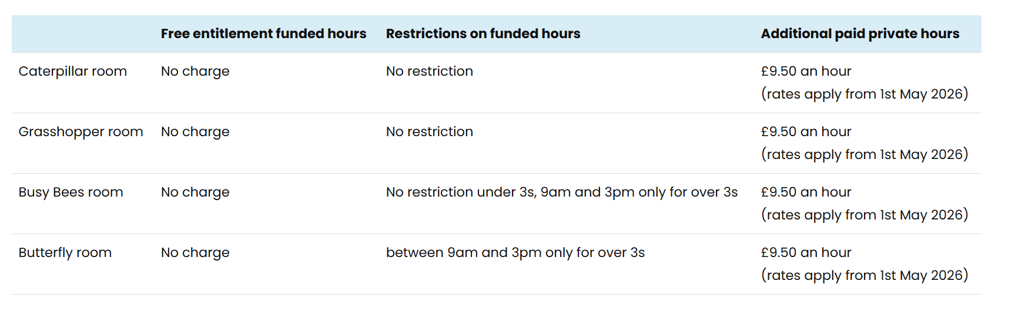
In order to use the funding with us parents are required to have done the following:
- Applied for a code through the government website (for working parent entitlement and two-year-old disadvantaged funding)
- Reconfirmed code every three months to confirm eligibility (for working parent entitlement)
- Completed a funding form ahead of every term, complete with attended hours, child and parents’ details, and how they wish to use the funding. This must also state if a child uses any funded hours at a shared setting.
We understand that funding can be quite complex especially for parents accessing it for the first time. Therefore, we will endeavour to help in anyway we can, including supporting parents with the application process and talking them through what contracted hours may look like to maximise their funded hours use.
An email is sent out to our families at the start of each funding year, to show the number of funded weeks in each term, and how many hours this equates to when spread over the term and holiday weeks. Our invoices and contracts clearly show free funded hours, and how much remaining to invoice for each term, so that parents are aware prior what they will be paying each month.
We do not charge our families any additional hidden or top up fees. Funded hours are completely free for our families to use. Any additional costs, are separate to the childcare hours, and every parent has the right to opt out of these. Our additional costs are as follows:
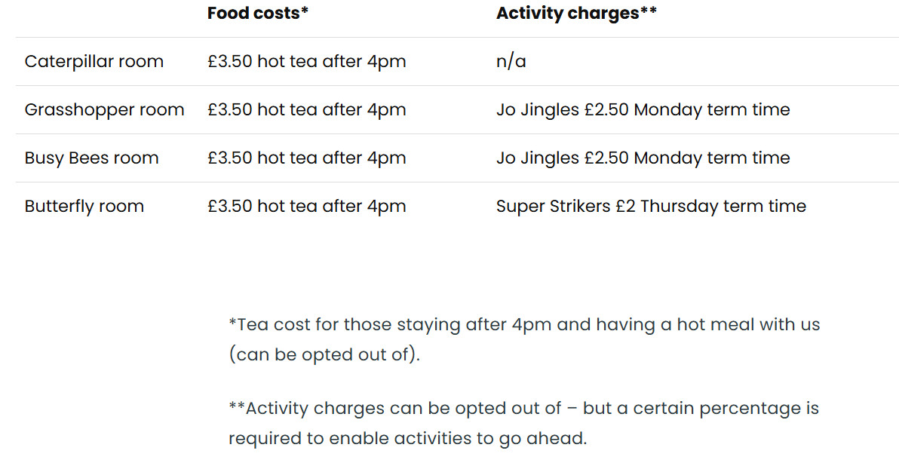
With our Jo Jingles and Super Strikers sessions every child in that room is able to participate regardless of whether their parent has paid for the session or not, and we would not discriminate against any child in this situation.

